## Workstations

Workstations are well described in the other manuals such as the Operator Manual. We just like to stress out that you can have the alarm mimic respond to which station you set it to. In the Matrix you can choose which station the mimic must represent (see Figure 8‑4). Also it is possible that it will serve as a fallback for another station.

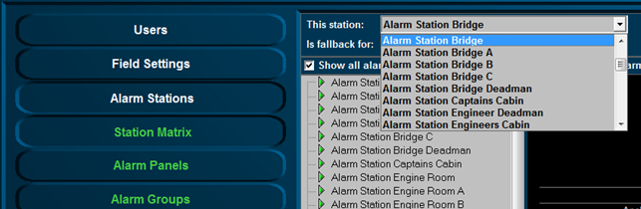

Figure 8‑4: Station Setting

At the duty-select button you can see if it is a station for the Engine room duty (see Figure 8‑5) or the Bridge (backup) duty (see Figure 8‑6).



Figure 8‑5: Engine room duty button



Figure 8‑6: Bridge (backup) duty button

Other than setting the station, you do not have to configure anything here. The configuration depends on the Matrix which will be discussed later.